

**KGiSL INSTITUTE OF TECHNOLOGY**

(Approved By AICTE, New Delhi, Affiliate to Anna University

Recognized by UGC, Accredited by NBA(IT)

265, KGISL Campus, Thudiyalur Road, Saravanampatti, Coimbatore-641035**.)**

**DEPARTMENT OF**

**ARTIFICIAL INTELLIGENCE AND DATA SCIENCE**

**NAAN MUDHALVAN - INTERNET OF THINGS**

**SMART PARKING**

**NAME: MADHUMITHA P**

**REG NO:** 711721243055

**NM ID:** au711721243055

**TEAM MENTOR:** Mr**.** Mohankumar M

**TEAM EVALUATOR:** Ms. Akilandeeshwari M

**Smart Parking Project Definition and Design Thinking Document**

**Problem Statement**

Our challenge is to develop a smart parking solution using IoT technology. We aim to monitor real-time parking space occupancy, offer dynamic parking guidance to users, and seamlessly integrate these features into a mobile app. The ultimate goal is to enhance the efficiency and convenience of public parking services, alleviating the common difficulties of finding available parking spaces in urban areas.

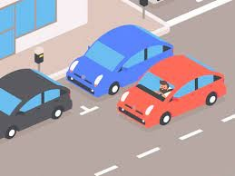

**Building Solution**

To transform the design and concept into an innovative smart parking solution, we'll follow a series of well-defined steps. This plan details how we'll put the design created in the previous phase into action.

**Step 1:** **Implementing IoT**

Real-time monitoring of parking space occupancy with accuracy is the goal.

Select the best IoT sensors based on their price, accuracy, and compatibility. It will be crucial to take into account elements like weather resistance, power efficiency, and ease of maintenance.

Determine the best location for the sensors within the parking lot before deploying them. To find high-traffic areas and any blind spots, conduct a site survey.

Data Transmission: To communicate sensor data to a central data aggregator step, establish a dependable data transmission technique, such as Wi-Fi, Bluetooth, or LoRa.

**Step 2:Mobile app development**

Goal of mobile app development: To offer consumers real-time parking advice and information.

Design and create a user-friendly mobile app interface that shows the availability of parking in real-time. Make sure the app provides directions to available parking spots and detours.

User Engagement: To continually enhance the usefulness of the app, provide systems for user feedback, such as ratings and comments.

Data visualization: Make parking availability accessible on a map so that users may quickly spot available spots.

**Step 3: Effective Parking Management**

Ensure that parking is used to its fullest potential while reducing traffic and waiting times.

Implement algorithms for data processing and analysis to verify the accuracy of the information on parking space availability.

Utilize Raspberry Pi or other systems to integrate with for real-time analysis of data gathered from IoT sensors.

Communication Protocol: Create a reliable and effective communication protocol to securely link the mobile app and IoT sensor system. Real-time updates should be supported by this protocol.

Make sure the mobile app receives real-time updates on parking space availability and tells users right away.

**Step 4: Testing and Quality Assurance**

Make that the system is error-free and matches the project's goals.

IoT sensors should be thoroughly tested to ensure their accuracy and dependability.

Mobile App Testing: To ensure a consistent and user-friendly experience, test the mobile app across a variety of platforms and devices.

Perform system integration testing to ensure that the mobile app and IoT sensor system can communicate properly.

**Step 5: Deployment of a Pilot**

Deploy the smart parking solution in a controlled setting in order to conduct preliminary testing and get user feedback.

Choosing a Pilot Location Select a modest parking lot or building to act as the first deployment location

User Feedback Gathering: Gather user and parking attendant feedback to make the necessary corrections and changes.

**Step 6: Full-Scale Implementation**

Deploy the smart parking system in a practical environment is the goal.

Choose Deployment Sites: Choose urban areas with high parking demand, then install the system there.

User Education: Educate users and parking attendants and offer them support

Establish a strategy for ongoing maintenance and monitoring to guarantee the solution's long-term functionality.

**Step 7: Continual Development**

Goal: Constantly improve the system based on user input and new technological developments.

Feedback Loop: Keep in touch with users through a feedback loop to answer concerns, collect ideas, and make iterative improvements.

maintain abreast of new developments in IoT, mobile app development, and data processing to maintain the system up to date and effective.

**Flowchart:**

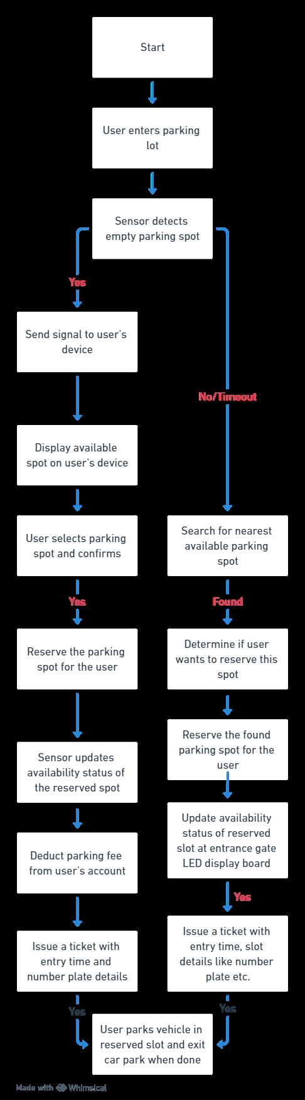

**Benefits of Smart parking:**

* Efficiency: Smart parking systems save time and fuel by quickly directing drivers to available parking spaces.
* Less Congestion: They reduce traffic jams by minimizing the time spent searching for parking spots.
* Data Insights: These systems collect data to help cities make informed decisions about traffic management.
* Improved Safety: Features like cameras and emergency buttons enhance safety in parking areas.
* Convenience: Real-time updates and remote payments make parking easier for drivers.

